Date: ____________, 2022

To Whom it May Concern:

The bearer of this letter ________________________(name) is a volunteer for the Chilliwack Ringette Association (CRA) and is required by CRA to submit a Criminal Record Check. The Chilliwack Ringette Association’s policy requires volunteers to have a Vulnerable Sector check.
Volunteers: Please bring this letter along with two pieces of government issued ID to the police or RCMP detachment where you reside. Your identification should show proof of your address.

Sincerely,
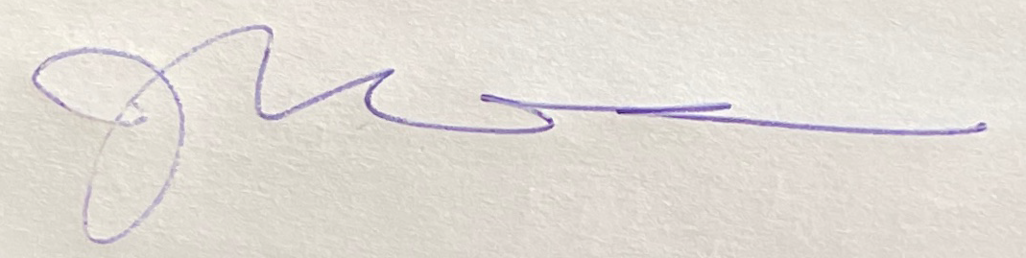

Julie Wilson
President
Chilliwack Ringette Association
604-701-7965
julie@chilliwackringette.ca

